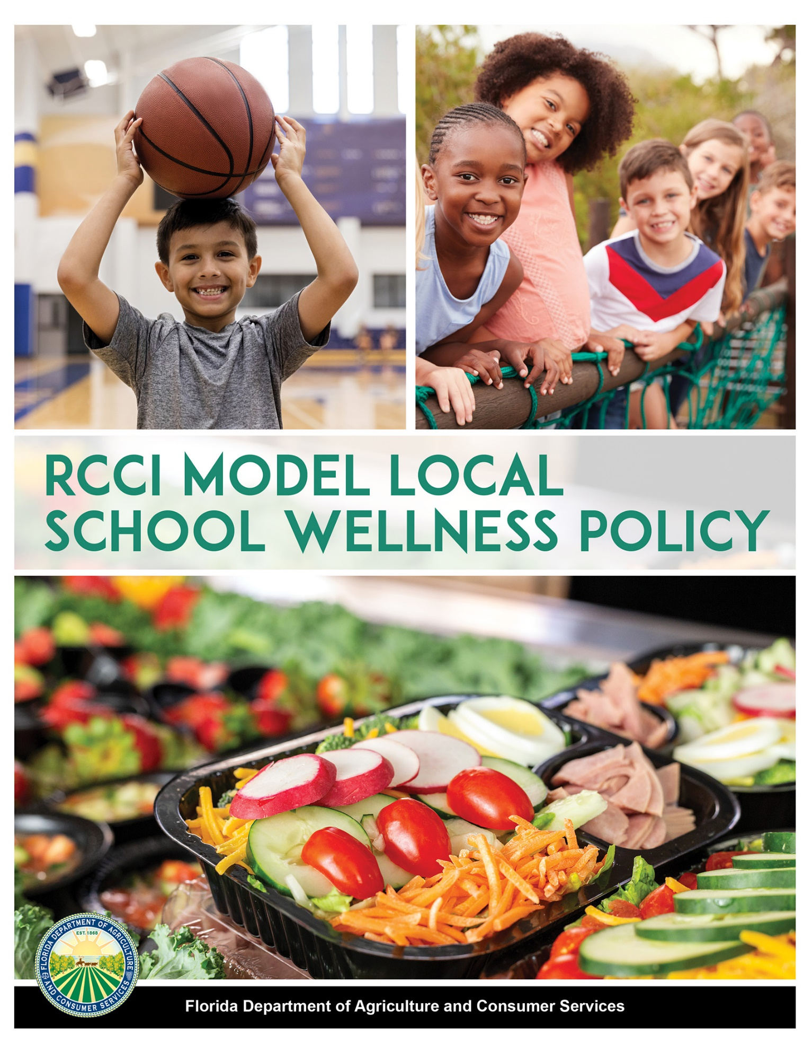
Using the RCCI Model Local School Wellness Policy
In drafting a Local School Wellness Policy, Residential Child Care Institutions (RCCIs) may choose to use statements from this model policy as written and/or revise them to meet local needs and reflect community priorities. Note there are 10 areas to consider and include.
The sections included below were designed to comply with provisions set forth in Section 204 of the Healthy, Hunger-Free Kids Act as well as the United States Department of Agriculture’s final rule, “Local School Wellness Policy Implementation Under the Healthy, Hunger-Free Kids Act of 2010.” This policy also incorporates Chapter 5P-2.002 of Florida Administrative Code (FAC), which addresses program responsibilities related to Competitive Foods.
- Please note statements written in red provide additional background on the regulations and are included in our model policy for informational purposes only.

- Statements in yellow should be customized to the individual RCCI. For example: “(The RCCI)” becomes “ABC Academy.”

RCCIs must fully comply with the requirements of the final rule.
Preamble
(The RCCI) recognizes that good nutrition and regular physical activity affect the health and well-being of all youth. Furthermore, research suggests that there is a positive correlation between a youth’s health and well-being and his/her/their ability to learn. Moreover, RCCIs can play an important role in the developmental process by which youth establish their health and nutrition habits by providing nutritious meals and snacks through the school meal programs, supporting the development of good eating habits and promoting increased physical activity.
(The RCCI) is committed to creating an environment that promotes and protects the overall well-being of all youth and staff. The guidelines listed below encourage a comprehensive wellness approach that is sensitive to both individual and community needs.
*Considerations from USDA:*
- Examples of the public may include a local dietitian, business representative, health care professional or community or civil leader interested in children, nutrition, education, health and physical activity.
- The RCCI is also encouraged to make available to the public and RCCI community, a list of names and position titles (or relationship to the RCCI) of individuals who are a part of the wellness committee; as well as the name, position title, and RCCI-based contact information of the lead individual (s) or coordinator(s) for the RCCI.

- Local School Wellness Policy Leadership

(The RCCI) will assemble a representative wellness committee that will meet bi-annually (specify frequency of meetings per year) to monitor and set goals for the development and implementation of its local school wellness policy. The policy shall be reviewed annually, and an updated copy shall be sent to the Florida Department of Agriculture and Consumer Services when a fundamental change or overhaul is made.
- The (List position title of designee and name of person (if applicable) shall ensure overall compliance with the local school wellness policy.
- Parents/guardians, youth, representatives of the school food authority, teachers of physical education, school health professionals, the school board, school administrators and the public shall be permitted to participate in the development, implementation, and periodic review and update of the local school wellness policy.
(The RCCI) will review and consider evidence-based strategies and techniques in establishing goals for nutrition promotion and education, physical activity and other RCCI-based activities that promote youth wellness such as a review of Smarter Lunchroom tools and techniques.
- Nutrition Promotion
Example Goals (only include measurable statements that the RCCI will be able to meet)
- Utilize Smarter Lunchroom tools and strategies to promote and reinforce healthy eating in the school environment, ensuring that messages are clear and consistent.
- Increase the number of on campus locations that youth can access useful nutrition information by 10-15% (specify a realistic percentage increase).
- Increase youth awareness of useful nutrition information from brochures, worksheets, handouts and digital content by 20-25% (specify a realistic percentage increase).

- Nutrition Education
Example Goals (only include measurable statements that the RCCI will be able to meet)
- Youth receive nutrition education that is interactive and teaches skills they need to adopt age-appropriate healthy eating behaviors. Classroom lectures, activities and youth participation are provided in nutrition and health classes. Classroom written tests (such as multiple choice, essay and fill in the blank) are given in the areas of nutrition. (Example topics include mindful eating, balanced meals, how to read nutrition facts labels).
- The staff responsible for nutrition education will be adequately prepared and participate regularly in professional development activities to effectively deliver an accurate nutrition education program as planned. Preparation and professional development activities will provide basic knowledge of nutrition combined with skill practice in program-specific activities and instructional techniques and strategies designed to promote healthy eating habits.
- The nutrition benchmarks included in Florida’s Physical Education Standards shall be taught as part of the structured and systematic unit of instruction during physical education classes and will be integrated into other subject areas (e.g., math, science) where there is a natural fit.

- Physical Activity
Example Goals (only include measurable statements that the RCCI will be able to meet)
- All elementary-aged (under 12) youth will have at least 20 minutes of daily recess. (The RCCI) will provide space, equipment and an environment conducive to safe and enjoyable play.
- Youth will have an increase in both the number and variety of physical activity opportunities offered to them.
- Staff will be encouraged to participate in 150 minutes of moderate-intensity aerobic activity (e.g., brisk walking, jogging, swimming) every week. Staff will be informed of the opportunity to participate in physical activity in afterschool programs and community events.
- Staff will be encouraged to provide short physical activity breaks between lessons or classes, at least biweekly (specify frequency of breaks per week), as appropriate.
- As applicable, (the RCCI) will take advantage of nearby facilities to provide expanded physical activity opportunities for youth and staff.

- Other RCCI-Based Activities
(The RCCI) will integrate wellness activities across the entire RCCI setting. These initiatives will include nutrition, physical activity and other wellness components so that all efforts work towards the same set of goals and objectives used to promote well-being, optimal development and strong educational outcomes.
Example Goals (only include measurable statements that the RCCI will be able to meet)
General Guidelines
- (The RCCI) shall consider the components of the Centers for Disease Control’s Whole School, Whole Community, Whole Child (WSCC) model in establishing other RCCI-based activities that promote wellness.
- (The RCCI) shall be in compliance with drug, alcohol and tobacco-free policies.
Eating Environment
- Youth will be provided an adequate amount of time to consume their meal with a minimum of 20 minutes after receiving their food from the line.
- (The RCCI) will provide nutritious, fresh, locally grown food that reflects Florida’s bountiful harvest.
- Convenient access to facilities for hand washing and oral hygiene will be available during meal periods.
Recycling
- (The RCCI) shall maximize the reduction of waste by recycling, reusing, composting and purchasing recycled products.
Employee Wellness
- (The RCCI) wellness committee will have a staff wellness subcommittee that focuses on staff wellness issues, identifies and distributes wellness resources and performs other functions that support staff wellness in coordination with human resources staff.
- All staff will be provided with opportunities to participate in physical activities and healthy eating programs that are accessible and free or low-cost.
Health Services
- A coordinated program of accessible health services shall be provided to youth and staff and shall include, but not be limited to, violence prevention, safety, communicable disease prevention, health screening, including body mass index, community health referrals, immunizations, parenting skills and first aid/CPR training.
Behavior Management
- (The RCCI) is committed to prohibiting the use of food as a reward, unless incorporated into an activity that promotes positive nutrition messages (such as a guest chef or field trip to a farm).
- Staff will not deny or require physical activity as a means of punishment.

- Guidelines for All Foods and Beverages Available During the School Day

(The RCCI) shall operate and provide food service in accordance with USDA’s National School Lunch Program (NSLP) standards and applicable laws and regulations of the state of Florida. The guidelines for reimbursable meals shall not be less restrictive than regulations and guidance issued by USDA.
General Guidelines
- All reimbursable meals will meet nutrition standards mandated by USDA, as well as any additional state nutrition standards that go beyond USDA requirements.
- Reimbursable meals will include a variety of nutrient-dense foods, including whole grains and fiber-rich fruits and vegetables, while accommodating special dietary needs and ethnic and cultural food preferences.
- To the maximum extent possible, (the RCCI) will participate in available federal school meal programs, including the SBP, NSLP, ASSP, AMP, and SFSP.
- Free, potable water will be made available to all youth during each meal service.
- (The RCCI) will source 5-10% of all fresh fruits and vegetables from local farmers when practicable.

*The following section is related to Competitive Foods, which are all foods and beverages sold on the school campus during the school day to youth outside of reimbursable school meals. These foods must comply with the nutrition standards for competitive food as defined and required in 7 CFR 210.11.
If this sponsorship does not currently sell competitive foods to youth and has no plans to do so in the future, the first statement below may be used in place of including the requirements for competitive foods.
Please include the applicable statement and remove the other information from the local school wellness policy*
Competitive Foods
- No foods or beverages are currently sold to the youth outside of the reimbursable meals. If competitive food/beverages are ever sold in the future, they will meet the competitive food (Smart Snacks in School) standards found at 7 CFR 210.11.

OR

- All foods and beverages sold on the school campus to youth outside of reimbursable school meals are considered “competitive foods,” and must comply with the nutrition standards for competitive food as defined and required in 7 CFR 210.11. Products will be assessed for compliance and approval using the Smart Snacks Product Calculator at https://foodplanner.healthiergeneration.org/calculator/.
  - School campus means, for the purpose of competitive food standards implementation, all areas of the property under the jurisdiction of the school that are accessible to youth during the school day.
  - School day means, for the purpose of competitive food standards implementation, the period from the midnight before, to 30 minutes after the end of the official school day.
- Competitive foods include items sold a la carte in the cafeteria, from vending machines, campus stores, snack bars and for in-school fundraisers.
- Unless being sold by (the RCCI’s) food service program, it is impermissible for any competitive food item sold to youth during the school day to consist of ready-to-eat combination foods of meat or meat alternate and grain products, as defined in 7 CFR 210.10 and 210.11. (FAC 5P-2.002)
*The final rule requires each LSWP to also include nutrition guidelines for all food and beverages available on the school campus during the school day that are not sold (i.e., foods provided for classroom parties and celebrations). This rule does not require RCCIs to address standards for food brought from home for individual consumption.
Standards for food and beverages available during the school day that are not sold to youth:

- Class parties or celebrations shall be held after the lunch period.
- (The RCCI) will limit celebrations that involve food during the school day to no more than one party per class per month.
- (The RCCI) will provide parents/guardians and staff a list of ideas for healthy celebrations/parties, rewards and fundraising activities.
OR
- Only foods that meet the Smart Snacks in School nutrition standards can be served.

*Florida’s competitive food rule allows sponsors to establish a special exemption from the competitive food standards for a certain number of day per school year. If this sponsorship does not participate in any food/beverage-based fundraisers, please select the first statement from the below section and remove the other information:*
Fundraising
- (The RCCI) does not hold fundraising events that involve food or beverage items.
OR
- Fundraising efforts will be supportive of healthy eating by complying with all applicable regulations and nutrition standards for competitive foods while also emphasizing the sale of nonfood items.
- No fundraisers that include the sale of food items will occur until thirty (30) minutes after the conclusion of the last designated meal service period.
- The board of directors is permitted to grant a special exemption from the standards for competitive foods as specified above for the purpose of conducting infrequent school-sponsored fundraisers, not to exceed the following maximum number of school days per school campus each school year:
School Type | Maximum Number of School Days to Conduct Exempted Fundraisers
Elementary Schools | 5 days
Middle School/Junior High Schools | 10 days
Senior High Schools | 15 days
Combination Schools | 10 days
- As applicable, each sponsor shall maintain records documenting the occurrence of any exempted school-sponsored fundraisers to demonstrate compliance with the rule found at FAC 5P-2.002.
*The food and beverage marketing rule requires local school wellness policies to establish only minimum standards for food and beverage marketing restrictions. State agencies and RCCIs may choose to adopt more stringent policies for food and beverage marketing. This does not apply to personal clothing or items, packaging of products brought from home or classroom materials used for educational purposes.*
*If no foods and beverages will be marketed, please select the first statement from the below section and remove the other information:*

- Policy for Food and Beverage Marketing
- No food or beverage marketing occurs in the program(s). If food/beverage marketing ever does occur, it will meet the competitive food (Smart Snack Standards).
OR
RCCI-based marketing will be consistent with policies for nutrition education and health promotion. As such, the following guidelines apply:
- (The RCCI) will only be allowed to market and advertise those foods and beverages that meet or exceed USDA’s Smart Snacks in School nutrition standards.
- Marketing activities that promote healthful behaviors are encouraged. Examples may include vending machine covers promoting water, pricing structures that promote healthy options in a la carte lines or vending machines, sales of fruit for fundraisers and coupons for discounted gym memberships.
- (The RCCI) will foster a cafeteria environment that promotes healthy eating, including the incorporation of fresh, locally grown foods into youth meals.
- (The RCCI’s) replacement and purchasing decisions will reflect the marketing guidelines mentioned above.

- Evaluation and Measurement of the Implementation of the Wellness Policy
(The RCCI’s) wellness committee will update and make modifications to the wellness policy based on the results of the annual review and triennial assessments and/or as local priorities change, community needs change, wellness goals are met, new health information and technology emerges and new federal or state guidance or standards are issued. The wellness policy will be assessed as indicated at least every three years following the triennial assessment.
Triennial Progress Assessments
(The RCCI) will assess the local school wellness policy to measure compliance at least once every three years. This assessment will measure the implementation of the local school wellness policy, and include:
- The extent to which (The RCCI) is in compliance with the local school wellness policy.
- The extent to which the local school wellness policy compares to model local school wellness policies; and
- A description of the progress made in attaining the goals of the local school wellness policy.
*At a minimum, RCCIs must annually inform and update the public about the content and implementation of the local school wellness policy. USDA encourages RCCIs to include a summary events or activities relating to the LSWP implementation, contact information for the designated LSWP official and information on how the public can get involved with the wellness policy committee.*

- Informing the Public
(The RCCI) will ensure that the wellness policy and most recent triennial assessment are always available to the public. (The RCCI) will also actively notify households (as applicable/possible) on an annual basis about any updates made to the wellness policy and the availability of the triennial assessment results, as well as provide information to the community about the RCCI nutrition environment.
Example Goals (only include measurable statements that the RCCl will be able to meet)

- (The RCCI) will ensure the most updated version of the wellness policy and triennial assessments are always available on its website for the public to view.
- Wellness updates will be provided to youth, parents/guardians, and staff, as applicable, in the form of handouts, (The RCCI) website, articles and/or newsletters, to ensure that the community is informed, and that public input is encouraged.
- As applicable, (The RCCI) will provide all parents/guardians with a complete copy of the local school wellness policy at the beginning of the school year.

- Community Involvement
(The RCCI) is committed to being responsive to community input, which begins with awareness of the wellness policy. (The RCCI) will actively communicate ways in which parents/guardians, youth, representatives of the school food authority, RCCI health professionals, staff, representatives from the local agriculture community, food and nutrition professionals and the public can participate in the development, implementation, and annual review of the local school wellness policy through a variety of means, including:
Example Goals (only include measurable statements that the RCCI will be able to meet)
- (The RCCI) will consider youth needs in planning for a healthy nutrition environment. Youth will be asked for input and feedback using surveys and attention will be given to their comments.
- (The RCCI) will use electronic mechanisms, such as email or displaying notices on (The RCCI’s) website, as well as non-electronic mechanisms, such as newsletters to ensure that all parents/guardians are actively notified of any updates to the wellness policy, as well as how to get involved and support the policy.
- (The RCCI) will invite the public and RCCI community to participate on the Wellness Committee.

Record keeping information is not required to be written into the wellness policy; however, the following documentation must be maintained and will be reviewed by the Florida Department of Agriculture and Consumer Services during an Administrative Review of the RCCI’s National School Lunch Program.
Record Keeping
Records to document compliance with the requirements of the local school wellness policy will include, but are not limited to the following:
- The written local school wellness policy.
- Documentation demonstrating compliance with community involvement requirements, including requirements to make the local school wellness policy and triennial assessments available to the public as consistent with the section on informing and updating the public; and
- Documentation of the triennial assessment of the local school wellness policy.

*Documentation demonstrating compliance with community involvement requirements may include a copy of the solicitation on the RCCI website. Documentation to demonstrate compliance with the public notification requirements may include a copy of the RCCI Web page where the LSWP has been posted or a copy of the RCCI’s newsletter.*

This institution is an equal opportunity provider.

